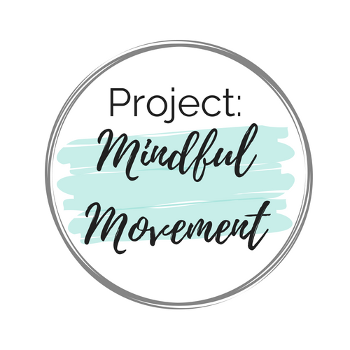

Dear [DONORS NAME],

Mindfulness-based programs can be a valuable component of school climate efforts by helping to develop a sense of community in the classroom. Research is showing that teaching children strategies to reduce stress, and promote relaxation should be a fundamental part of a successful education program. This year, our classroom will be participating in the mindfulness-based curriculum, Project Mindful Movement, that will not only improve the lives your children in our classroom, but at home too!
Project Mindful Movement is a program created for students and designed for educators and parents to easily implement mindfulness-based practices into their routines. The goal is to help students cultivate a growth mindset, encourage social and emotional learning, as well as improve positive mind & body connections through breathing practices, movement poses & stretches, positive language affirmations, and mindfulness-based activities.

Help bring mindfulness to our classroom!
Just a small donation of $1-5 per student will help me fund the full program for the entire [ENTER SCHOOL YEAR HERE] school year and allow me to introduce your student to techniques to help them grow and flourish not only academically but physically and mentally as well!
You can make contributions directly on the Project Mindful Movement donation page by visiting the link below, clicking on the dropdown menu, finding my name, [INSERT YOUR NAME AS REQUESTED ON THE PMM DONATION PAGE], and entering the amount of your choice.
Donation link: https://bit.ly/2Z3GaGR
Sincerely,
[INSERT YOUR NAME HERE]
Benefits of a mindfulness-based practice in the classroom

Academic Performance
Improves focus and attention, time on task and supports positive academic outcomes.

Physical Health & Wellness
Increase physical well-being and physical fitness as well as balance, coordination, flexibility and strength.

Mental Health & Resilience
Reduces anxiety, stress response and depression. Helps improve coping strategies to build resilience.

